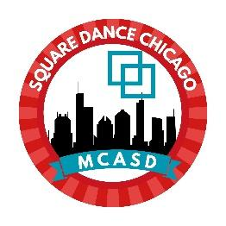
MCASD Caller School Scholarship

A $75 scholarship for reimbursement of caller school fees is available for those completing in the Chicago Caller School session Aug 28 – 30, 2026, who are also members of a member club of the Metropolitan Chicago Association of Square Dancers. Check with your club for additional scholarship support.

Name
Email
Phone
Club Name
Date submitted

Payment option:
Check to be mailed? | ☐
Mailing address
Zelle direct deposit? | ☐
Zelle account email or phone number

Chicago Caller School Authorized Signature:

Submit application to: christine.steffy@gmail.com
Deadline to apply: Sept. 30, 2026

Version 1.0 2026.0731

